**Process to access FIGMA**

Create an account at: <https://www.figma.com/> with KP email id.

Figma sends out an email to verify your KP email id

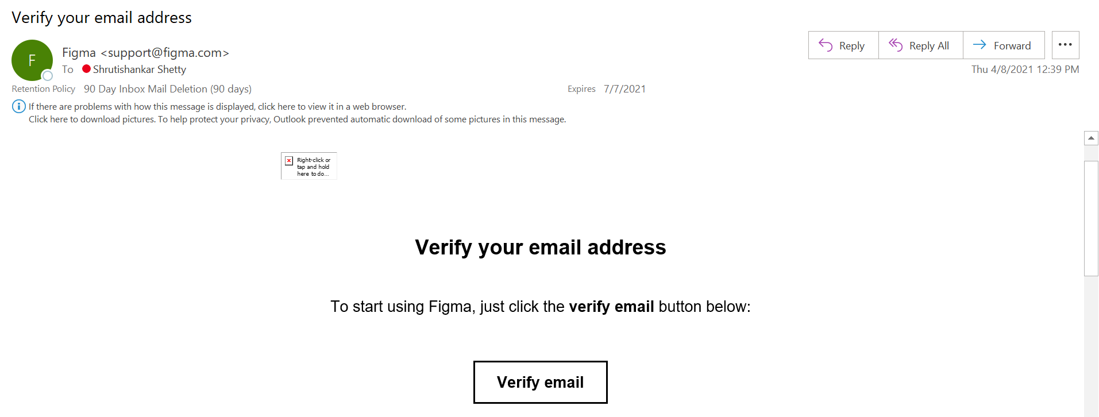

Once it is verified the welcome email is sent by Figma.

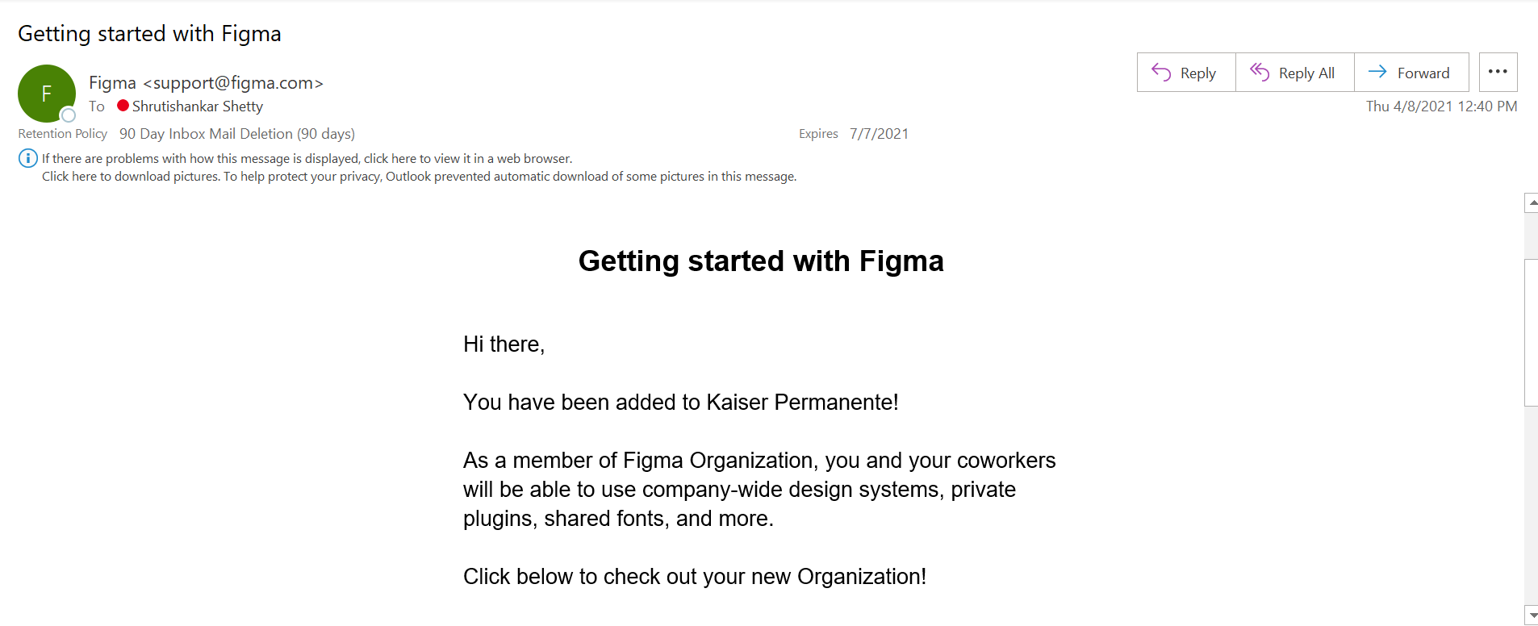

Few links that you should have access to:

* [BCSSP_Phase 2_Sitemap – Figma](https://www.figma.com/file/fLwkuRL84PKuYMvVDZSgrR/BCSSP_Phase-2_Sitemap?node-id=0%3A1)
* [20190816_BCSSP_END_TO_END_UX – Figma](https://www.figma.com/file/j8OemiJCgmUsM0kkQmqfYs/20190816_BCSSP_END_TO_END_UX?node-id=585%3A3813)
* [IA Global Header – Figma](https://www.figma.com/file/8HnU9dySZELfisvNQmX7Ug/IA-Global-Header?node-id=14%3A263)
* [Recently viewed – Figma](https://www.figma.com/files/850072049711946100/recent?fuid=962074074342562113)